Em Prof Robert Pascoe
The future is a foreign country
Robert Pascoe is the president of the Royal Historical Society of Victoria, passionate in his support of community history.
We need to value the work of the state’s 340 affiliated historical societies and the RHSV’s 1200 members. Knowing our past better, truth-telling, is a sure pathway to imagining the future we want to create for our grandchildren and their children. To rephrase L. P. Hartley’s famous line, ‘The future is a foreign county; they will do things differently there.’ The kind of society we want to become is hidden in plain view in our past.
From 1989 to 2005, Pascoe was the foundation dean of arts at Victoria University, in Melbourne’s West, offering innovative programs in community development, computer mediated art, cultural studies, multimedia, psychology, and social work. In 2025 Pascoe received an Australian Historical Association Lifetime Achievement Award for his work in promoting history in Melbourne’s West.
Pascoe continues to research and write history. He is the author or co-author of three dozen books and technical reports in history, educational management, and popular culture. Here are some:

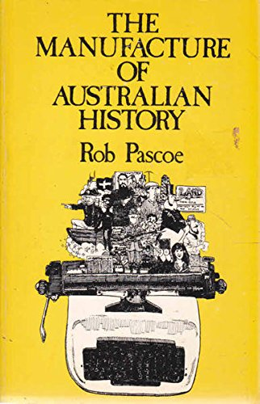
Pascoe’s first book, The Manufacture of Australian History (Oxford University Press, 1979) was influential in the reshaping of the History discipline in Australia during the 1980s

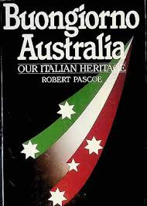
Buongiorno Australia (Greenhouse, 1987), commissioned by the Vaccari Italian Historical Trust, was the first general social history of the Italians in Australia and is still widely quoted
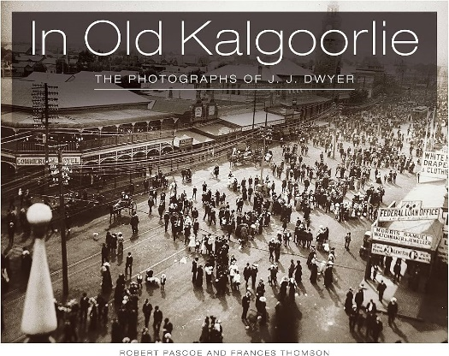

An account of one of Australia’s iconic towns, In Old Kalgoorlie (Western Australian Museum, 1989, 2010) has consistently been the top-selling book in the Museum’s bookshops

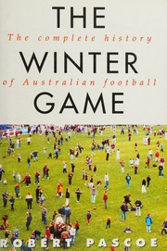
The first national account of Australian football, The Winter Game (Text, 1995) wove together sports and social history
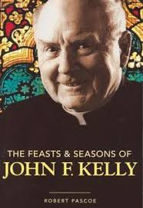
The Feasts & Seasons of John F. Kelly (Allen & Unwin, 2006) is one of Pascoe’s three biographies to date, alongside those of builder Luigi Grollo and civil engineer Nat Bonacci

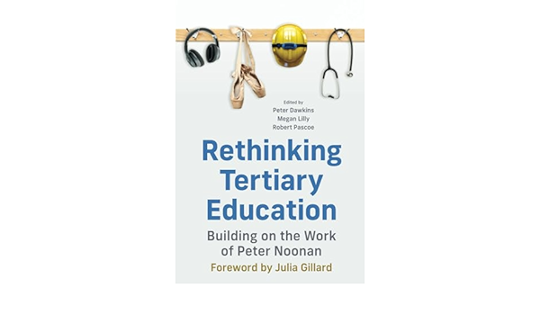

Pascoe served as a contributing author and co-editor of Rethinking Tertiary Education (Melbourne University Publishing, 2023), offering a radical agenda for reforming Australia’s universities and TAFE
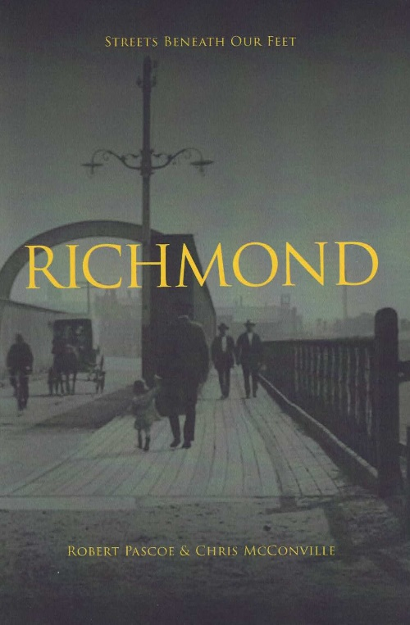

Researched and written with his colleague of four decades, Chris McConville, Richmond (Connor Court, 2026) is the first in their Streets Beneath Our Feet series, revealing the history on show to flaneurs walking through some of the world’s most interesting neighbourhoods. Go to www.streetsbeneathourfeet.com for further details.

